Coursework Submission Coversheet

Please use this coversheet for all coursework assessment submissions.
You should copy the completed coversheet into your assessment document as the first page and save as one single document for submission.
If you require full guidance on coursework submission, please consult the Code of Practice on Assessment (available in your Programme Organisation in Minerva). In particular:
- See section 3.3d for the full policy on penalties for exceeding assessment limits (e.g. word count).
- See section 3.3e for the full policy on penalties for late submission of coursework.
To complete this coversheet, please provide the following information:
Module code: OCOM5204M
Module title: Data Mining and Text Analytics
Assessment title: Assessment 2: Research project proposal
Your 9-digit Student ID number: 201692702
Word count or minute count: 4,687 words
Submission date: 26 January 2024
Please note that by submitting this piece of work you are agreeing to the University’s Declaration of Academic Integrity.

Research hypothesis and objectives
This proposal aims to apply language model text generation methods to augment existing hand-labelled data in the field of online sexism, a type of online abuse that is both widespread and harmful (Kirk et al. 2023).
As social media platforms seek to eliminate online abuse (including online sexism) to both comply with government regulation (Depart for Science, Innovation and technology, 2023) and to limit the business from any bad practice (which may put revenue streams at risk), the NLP task of text classification in this space at scale becomes not only morally, but commercially, more pressing. Beyond the binary task of determining whether an online comment is sexist or not, it is also important that any moderation or censorship be explainable, as it provides transparency to users and is useful for monitoring the trends of harmful online content (European Commission, 2024).
The goals of this proposal are to:
- Demonstrate that generating synthetic data from a small batch of hand-labelled data for the detection of online sexism can lead to improved text classification performance across multiple classifiers (e.g. BERT-based, Flan-T5 based)
- Demonstrate that this strategy can help text classification models distinguish between different types of sexism (e.g. “threats” vs “prejudiced discussion”) more effectively
- Identify the most effective strategy to generate this type of synthetic data, as measured by its impact on classifier performance

The performance impact of data augmentation in this context will be measured by comparing the performance of a text classification model finetuned on the hand-labelled data only against another model (identical in architecture) finetuned on the hand-labelled and synthetically augmented data. In measuring performance, minimising false negatives (sexist comments that are classified as not-sexist) is the primary objective; however, this needs to be balanced against minimising false positives (not-sexist comments that are classified as sexist) so that censorship is limited and user engagement is not discouraged. The F1-score provides a balanced score that will be used to compare the performance of each model.

Background
Generation of synthetic data in support of “Data Augmentation” (DA) in the field of NLP is gaining increasing attention as researchers seek to mitigate the impact of limited training data (Feng, et al., 2021). The strategy can be employed in situations where researchers may be constrained from commissioning larger hand-labelled data, or where such data is not available (for example in the case of languages with limited resources) (Feng et al., 2021).
Researchers may be constrained from acquiring larger hand-labelled datasets due to a variety of reasons, though time and cost are usually the primary factors. In the field of online abuse research, however, an additional consideration arises – the impact of the research material on the human labellers’ mental and emotional wellbeing. The negative impact on the mental health on social media content moderators from abusive or distressing content is clear (Spence, et al., 2023), and this impact may be a moral consideration that restricts researchers’ ability to obtain a larger dataset.
Data Augmentation may also be useful in the case imbalanced datasets, where data from under-represented classes may be over-sampled to help redress class imbalance. Both problems are prevalent in the study of online sexism, and both can be mitigated by obtaining a larger dataset through data augmentation (Kaddour & Liu, 2024).
The use of a small hand-labelled dataset to ‘bootstrap’ a larger dataset to train a machine learning model is not a new idea. One example of this is the data augmentation used widely in computer vision, where perturbations (such as rotations, image flipping, variations in contrast, etc.) are applied to existing images to both grow the size of the dataset as well as to help the model become more robust to changes in data and avoid overfitting. Due to the nature of language, these techniques are not directly applicable to NLP (Feng et al., 2021).
Large language models (LLMs) have been demonstrated to be increasingly competent at natural language tasks (Radford et al., 2019). However, LLMs are trained for “general language” tasks on common corpora, which results in strong performance in many tasks (Radford et al., 2019) but may be less performant on niche fields (such as online sexism). Transfer Learning allows LLMs that would normally be too large for individuals or universities to train (or afford to train) to be finetuned, increasing the competence of the model at specific niche tasks or languages (Radford et al., 2019). Additionally, the ability of decoder-only LLMs to generate text within strict parameters (through prompting, for example) lends itself nicely to data augmentation for the task of text classification in niche fields where pre-existing training data is not readily available.
One limitation of these commercial models are the constraints placed on them that prevents these models from generating offensive and abusive text (see Appendix) – while these limitations are introduced for good reason, it renders these models unsuitable for the purpose of synthetically augmenting text data relating to online sexism. For this reason, this proposal focuses on finetuning open-sourced models, which produces lower quality text “out-of-the-box” but is not constrained by the same limitations. Compounding this issue is the fact that the proportion of abusive content online, whilst difficult to estimate, could be lower than 1% (Kirk et al., 2023). This means that pretrained LLMs, which are typically trained on corpora that include typical web content such as Wikipedia articles (Radford et al., 2019), may not be frequently exposed to online sexism comments and may perform poorly “out-of-the-box”, requiring further pretraining.
This proposal builds on the work presented SemEval 2023, “Explainable Detection of Online Sexism” (Kirk, et al., 2023), which found that while most contestants were able to build text classifiers that were successful at determining whether a comment was sexist or not, most models were significantly less successful at classifying the “category of sexism” displayed in those comments. This proposal hypothesises that this lower performance was driven, in part, by the lack of data available for text classifiers to be trained, which can be overcome through synthetically augmenting the hand-labelled data.

Importance and contribution to knowledge
Online sexism against women is a growing and harmful phenomenon (Kirk et al., 2023), and the development of abusive content detection at scale is of growing interest to social media platform hosts (Vidgen et al., 2019).
Moderation of online comments must strike a fine balance between being too authoritarian, resulting in the perception of the oppression of free speech, and not being firm enough, resulting in the harm discussed previously. When a comment is censored or a user of a social media platform is banned, it can be frustrating to not know the reason for the ban or censorship, which is what happens today due to the way that moderation at scale leverages machine learning (Vidgen et al., 2019). Indeed, the perception that a machine learning algorithm is a “black box” can be both frustrating for users and businesses that rely on user engagement as a driver of commercial success. Explainable AI is a field of research that seeks to address this need.
A key feature of machine learning algorithms is its ability to learn in a “non-deterministic” way that makes it difficult for humans to ‘trace’ its logic and reasoning. This characteristic obfuscates bias in the algorithm and erodes trust from users, particularly when the algorithm provides an unexpected outcome. Explainable AI refers to the field of research in AI, not just in NLP, that focuses on providing some reasoning or logic to the decisions made by the algorithm (Vidgen et al., 2019). The approach to Explainable AI taken in SemEval 2023 Task 10 (Kirk, et al., 2023) was through granular classification – labelling comments not merely with “sexist” and “not-sexist”, but with “categories of sexism”. This approach allows existing architectures to continue to classify text in the usual manner but allows users to begin to explain why certain comments may be deemed sexist or not.
The benefits of a robust and accurate classifier model that can distinguish not only whether a comment could be considered sexist or not, but also provide clues to how that comment may be interpreted as sexist (or not) are multiple. The most obvious benefit is the ability to help protect vulnerable users of online platforms (such as social media) from the harms of online sexism discussed earlier. Benefits extend to the online platforms, as investors and advertisers (a key source of revenue) will be more likely to partner with platforms that offer broad reach while minimizing risk of offending their customer-base or falling foul of government regulation. Online platforms will also be able to benefit from reducing human content moderation teams, which represent both a financial and moral benefit as discussed earlier. A third group that may benefit from this research could be the offenders, who may find an explanation of why their comments are deemed sexist educational. Finally, the impacts of this research need not be restricted to the domain of online sexism, and could extend out more broadly to online abuse or even sentiment analysis in general.
This research does raise some risk of harm; generating synthetic data to augment existing sexist comments could be used to spread online sexism at scale. It is the hope of this proposal, however, that the improved performance of text classification models enabled by this research outweighs and even negates the potential harm it may enable. This potential harm may be further mitigated by research in detecting text generated by LLMs (Wu, et al., 2023).

Pilot study
A pilot study was conducted as a proof-of-concept to demonstrate that the generation of synthetic comments belonging to different “categories of sexism” was possible, and that the comments generated are functionally indistinct from those in the hand-labelled dataset. The prompts used to generate the synthetic data will be used as the label for the “category of sexism” and so it was important that the generated text falls believably within that category.
The data used in the study is taken from the “Explainable Detection of Online Sexism” (EDOS) dataset provided by Kirk et al. (2023) for SemEval-2023 Task 10: Explainable Detection of Online Sexism. The dataset was extracted from two social media platforms that encourage online discourse: Gab (https://gab.com), an “alt-tech” social networking site established in 2016, and Reddit (https://www.reddit.com), a network of communities based around shared interests and topics. Both social media sites were mined for “general text” (i.e. text or discussions that are broadly representative of the sites); however, 250,000 texts were also randomly sampled from each of four Reddit subcommunities identified in prior work (Lilly, 2016) as most likely to share sexist commentary. A subset of the sampled comments were then hand-labelled by 19 expert labellers, resulting in 20,000 labelled comments. These comments were labelled with one of five labels, as shown in Figure 1.
As Kirk, et al. (2023) share, it is encouraging to observe that even a dataset biased to deliberately include sexist comments shows that there is a strong class imbalance, with “not-sexist” comments being three times more common than “sexist” comments, as shown in Figure 1 below.
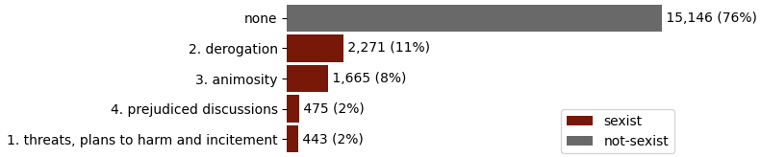
Figure 1: Class imbalance in the hand-labelled dataset
Examples of comments by category are listed below to provide an indication of what the categories concretely translates to in the Appendix.
The LLM chosen for this pilot study was the transformer-based GPT-2 language model developed by OpenAI (Radford, et al., 2019), which comes in a range of variants, the largest of which (GPT-2 XL) contains 1.5B parameters. In order for training to be conducted on a personal computer with a discrete GPU, GPT-2 Medium (the 355M parameter variant) was used in this pilot study. This is a compromise in performance, as the larger variants (such as GPT-2 Large and XL) are more performant and it is proposed that the larger variants be used in the broader study.
To remove as much noise as possible for finetuning the GPT-2 Medium model, the data was cleaned to remove emojis and tilde (~) characters as initial tests without these characters removed yielded a greater proportion of nonsensical statements generated by the LLM. While this is acceptable for a pilot study, the proposal suggests that if greater resources are available, enabling the finetuning of larger LLMs (e.g. GPT-2 XL, Mistral-7B), that these characters be left in the training data as emojis can be used effectively convey emotion and the tilde (~) is used to indicate emphasis (e.g. italics or bolding of words) and be used to place greater weight on these emphasised words.
The data was further pre-processed to adjust for class imbalance in the finetuning process; this was achieved by first splitting the data into a train-dev-test split according to the split labels provided in the dataset. The training data was then analysed to determine the volume of largest “sexist” category (“2. Derogration” with 1,590 records); the “not-sexist” data was then under-sampled to the same volume. Balancing the data mitigates the potential of the LLM drawing from “not-sexist” examples when being prompted to generate “sexist” comments (ValizadehAslani et al. 2022).
The “category of sexism” and the text were combined to create training prompts in a “Question and Answer” format as shown in Table 1.
“Category of sexism” | Prompt
none | “[Task]: Write a not sexist comment.  [Answer]: {text}”
1. threats, plans to harm and incitement | “[Task]: Write a sexist comment that is threatening to women.”  [Answer]: {text}”
2. derogation | “[Task]: Write a sexist comment that is derogatory to women.  [Answer]: {text}”
3. animosity | “[Task]: Write a sexist comment that shows animosity toward women.”  [Answer]: {text}”
4. prejudiced discussions | “[Task]: Write a sexist comment that is part of a prejudiced discussion against women.  [Answer]: {text}”
Table 1: Prompts used in training GPT-2 Medium for each category of sexism
A “Question and Answer” format was chosen for the prompting to encourage short sentences of generated text and to guide the model to generate text for a specific “category of sexism” – akin in some senses to a type of reverse text classification task. Additionally, this format of prompting results in the same “[Task]” text being associated with multiple examples for the purpose of guiding the model to associate comments of a similar category together. To facilitate ease of training across different models (e.g. GPT-2, GPT-2 Medium), the data was saved as a text file with each prompt being written into the file followed by two newline breaks to delimit each example.
Training was conducted over 50 epochs with training loss (which defaults to the negative log likelihood) converging from ~2.7 to ~0.6 after 13,500 training steps. The entire model was trained as there was insufficient time to explore the effects of freezing different layers in finetuning for the pilot study, the investigation and experimentation of which is recommended for the full study.
After training, manual prompts matching those shown in Table 1 were provided to the model and outputs that were roughly within the range of each category was able to be successfully generated alongside some nonsensical results (see examples provided in Appendix; trigger warning).
The pilot study was able to demonstrate that generation of synthetic texts to augment data for text classification purposes on sensitive topics (such as online sexism) is possible with open-source LLMs that may not have been exposed to sufficient examples in its underlying training.
The pilot study also highlights that the finetuning process for this type of text is non-trivial, and that further investigation into text preprocessing, identifying model layers for freezing, and hyperparameter tuning is required to yield higher quality results.
Finally, the pilot study explored only one LLM architecture; the full study will be expected to explore the effectiveness of different LLM strategies such as full-transformer architectures (e.g. Flan-T5) and Generative Adversarial Networks.

Programme and methodology
This proposal suggests that the research be segmented broadly into six phases to be conducted by a team of two researchers (referred to in this section as “Researcher 1” and “Researcher 2”) and is based broadly on the CRISP-DM (Cross Industry Standard Process for Data Mining) framework. To establish a regular cadence of progress, it is suggested that updates from the researchers to the sponsor(s) of this study be sent on a monthly basis.
Phase 1: Understanding existing research and re-defining research need (0.5 months)
The project should begin with a more exhaustive review of prior and ongoing efforts in the research of data augmentation for NLP tasks and should take approximately 2 weeks (or half a month) for both researchers to undertake. This phase should build upon the exploration and summarisation of the research in the field of NLP data augmentation detailed in this proposal but should also include a more extensive review of methods across both NLP and non-NLP fields such as computer vision. The review will need to evaluate different methodologies currently proposed in the field of text generation and compare the relative strengths and weaknesses of synthetic text generation to other data augmentation strategies such as synthetic data-labelling (i.e. machine labelling real datapoints).
Researcher 1 will focus on existing research into data augmentation strategies across both NLP and non-NLP fields. Researcher 2 will focus on existing research on text generation within specific constraints (e.g. prompting, Question-Answering, etc.) and identify the strengths and weaknesses of these approaches in data augmentation.
At the end of this phase, both researchers will combine their findings into a single research summary that will define the specific applications where text generation for data augmentation is most suitable.
Phase 2: Language model architecture selection (0.5 months)
The second phase will be centred around identifying the most promising candidate architectures for data augmentation by text generation, as well as identifying the text classifier model that will be used to empirically measure the performance impact of data augmentation. It would be preferrable for the researchers to consider a range of architectures, rather than simply following decoder-based models as was demonstrated in this pilot study to explore multiple approaches, but this will be determined by the findings in Phase 1.
It is important to note that maximizing the performance of the text classifier through finetuning or tweaks in architecture is not the focus of this proposal; therefore, it is recommended that the researchers simply implement the top performing models as highlighted by the findings of Kirk, et al. (2023) in SemEval-2023 Task 10 (Task B).
Researcher 1 should focus on identifying at least three language models that could be finetuned for the purpose of data augmentation by text generation and identify the size variant (e.g. GPT-2 Medium or GPT-2 Large) most suitable for quick prototyping.
Researcher 2 will focus on implementing at least two text classifier models suitable for measuring the performance impact of data augmentation; once this is complete, attention should be turned to identifying one other candidate language model for finetuning. Researcher 2 is also expected to define the metrics to measure this performance improvement and is encouraged to use the metrics identified by Kirk, et al. (2023).
Phase 3: Prompt finetuning and data preparation (1 month)
The researchers will then spend a month on the data understanding and preparation stages described by the CRISP-DM framework; this stage is intertwined with discovering and finetuning the best prompts or document formats for the data to be pre-processed into. The EDOS dataset has already been provided with some preprocessing, however, there are multiple versions provided and the researchers will need to decide on which format will be most appropriate for the research task. Additionally, the researchers may find that sourcing external data (e.g. from other social media platforms or other existing datasets) may be necessary or desirable, and this phase provides the time for the researchers to find, explore and preprocess those datasets as required. To expedite the data exploration phase, tools such as RapidMiner or Weka² should be used.
The most time-consuming portion of this phase will be identifying a prompt (or other format) strategy that will yield the most consistent and predictable results from the generative language models. While the research conducted in Phase 1 will be instructive on prior efforts, the researchers will need to experiment with multiple approaches to identify a strategy for this task.
As this phase involves a trial-and-error approach, it is expected that the researchers will prototype approaches on smaller versions of the selected models (e.g. GPT-2 Small) and investigate efficient finetuning methods (e.g. PEFT) to reduce compute (and financial) cost as well as time savings.
Phase 4: Model finetuning (2 months)
This phase is aligned with the ‘modelling’ stage of CRISP-DM, where the researchers will spend most of their time and efforts on iterating toward a most optimal model, with each researcher focusing their attentions on half of the models identified as being the most appropriate (and most promising) for data augmentation by generative text. The finetuning may involve iteratively freezing pre-trained layers from pre-trained models to find the best finetuning approach or even finetuning all layers of the models.
The timeframe for this phase is the longest, with researchers needing to find the right balance between model size, computing power, and time taken to finetune each model. We expect the best performance from the largest models, though this also entails acquiring more compute power, waiting longer for the model to finetune, or both.
Each researcher will finetune half of the selected models each and will develop each model until they are satisfied that each finetuned model is able to perform as highly as possible across these dimensions:
- “Human-like”-ness of the generated text (i.e. grammar, spelling, and coherence standards in-line with the EDOS corpora)
- Predictability of the generated text (i.e. models do not generate text that fluctuate wildly in quality from one generated text to another)
- Strictly within the bounds of the sexism categories as defined in the EDOS dataset
The extended timeframe in this phase will allow researchers to re-process the data as the model or prompt strategy evolves and this iterative process is expected to continue throughout this phase until a strategy begins to emerge as the most performant.
Phase 5: Cross-checking results and experiments with other datasets (1 month)
The researchers will then evaluate the results they have achieved with each other to allow cross-pollination of ideas and approaches as Phase 4 may have been conducted in some isolation. This also allows the researchers to investigate adapting approaches from one model to another as well as ensemble approaches.
The researchers are asked to briefly evaluate the performance of the generative models on other non-related labelled text sentiment datasets to explore how well the model or framework may perform “out of the box” to other NLP fields that may need data augmentation.
Phase 6: Evaluation and write-up (1 month)
The final phase will have both researchers converging on a single model or approach (in the case of ensemble methods) and evaluating the performance of the model, as measured by the impact on the performance of a pretrained text classifier with and without data augmentation.
The researchers will then present their findings in the form of a research paper.

1-page workplan diagram

References
Kirk, H., Wenjie, Y., Vidgen, B. and Röttger, P. 2023. SemEval-2023 Task 10: Explainable Detection of Online Sexism. In: Proceedings of the 17th International Workshop on Semantic Evaluation (SemEval-2023), 13/14 July 2023, Toronto. [Online]. Toronto: Association for Computational Linguistics, pp.2193-2210. [Accessed 24 February 2024]. Available from: https://aclanthology.org/2023.semeval-1.305/
Department for Science, Innovation and Technology, Department for Digital Culture, Media & Sport. 2023. A guide to the Online Safety Bill. [Online]. [Accessed 23 February 2024]. Available from: https://www.gov.uk/guidance/a-guide-to-the-online-safety-bill
European Commission. 2024. DSA Transparency Database. [Online]. [Accessed 23 February 2024]. Available from: https://transparency.dsa.ec.europa.eu/
Feng, S.Y., Gangal, V., Wei, J., Chandar, S., Vosoughi, S., Mitamura, T. and Hovy, E. 2021. A Survey of Data Augmentation Approaches for NLP. In: Findings of the Association for Computational Linguistics: ACL-IJCNLP 2021, August 2021. [Online]. Association for Computational Linguistics, pp.968-988. [Accessed 24 February 2024]. Available from: https://aclanthology.org/2021.findings-acl.84
Spence, R., Bifulco, A., Bradbury, P., Martellozzo, E. and DeMarco, J. 2023. The psychological impacts of content moderation on content moderators: A qualitative study. Journal of Psychosocial Research on Cyberspace. 17(4), pp. Article 8
Kaddour, J. and Liu, Q. 2024. [Pre-print]. Synthetic Data Generation in Low-Resource Settings via Fine-Tuning of Large Language Models. [Online]. arXiv. [Accessed 24 February 2024]. Available from: https://arxiv.org/abs/2310.01119
Radford, A., Wu, J., Child, R., Luan, D., Amodei, D. and Sutskever, I. 2019. Language models are unsupervised multitask learners. OpenAI blog, 1(8), pp. 9
Vidgen, B., Harris, A., Nguyen, D., Tromble, R., Hale, S. and Margetts, H. 2019. Challenges and frontiers in abusive content detection. In: Proceedings of the Third Workshop on Abusive Language Online, August 2019, Florence. [Online]. Florence: Association for Computational Linguistics, pp.80-93. [Accessed 25 February 2024]. Available from: https://aclanthology.org/W19-3509
Wu, K., Pang, L., Shen, H., Cheng, X. and Chua, T-S. 2023. LLMDet: A Third Party Large Language models Generated Text Detection Tool. In: Findings of the Association for Computational Linguistics: EMNLP 2023, December 2023, Singapore. [Online]. Singapore: Association for Computational Linguistics, pp.2113-2133. [Accessed 24 February 2024]. Available from: https://aclanthology.org/2023.findings-emnlp.139
ValizadehAslani, T., Shi, Y., Wang, J., Ren, P., Zhang, Y., Hu, M., Zhao, L. and Liang H. 2022. [Pre-print]. Two-stage fine-tuning: A novel strategy for learning class-imbalanced data. [Online]. arXiv. [Accessed 25 February 2024]. Available from: https://arxiv.org/abs/2207.10858
Kirk, H., Wenjie, Y., Vidgen, B. and Röttger, P. 2023. SemEval-2023 Task 10: Explainable Detection of Online Sexism. GitHub. [Online]. [Accessed 16 February 2023]. Available from: https://github.com/rewire-online/edos/tree/main
Lilly, M., 2016. ‘The World is Not a Safe Place for men’: The Representational Politics of the Manosphere. [Online]. University of Ottawa. [Accessed 24 February 2024]. Available from: http://hdl.handle.net/10393/35055

Appendix
Demonstration of content restrictions on Closed-Source Generative Language Models
Closed-source models available online today are unsuitable for the generating synthetic data that mimics sexist commentary online due to the restrictions placed upon them by the platform hosts to prevent the spread of abuse and limit the potential harms from the models.
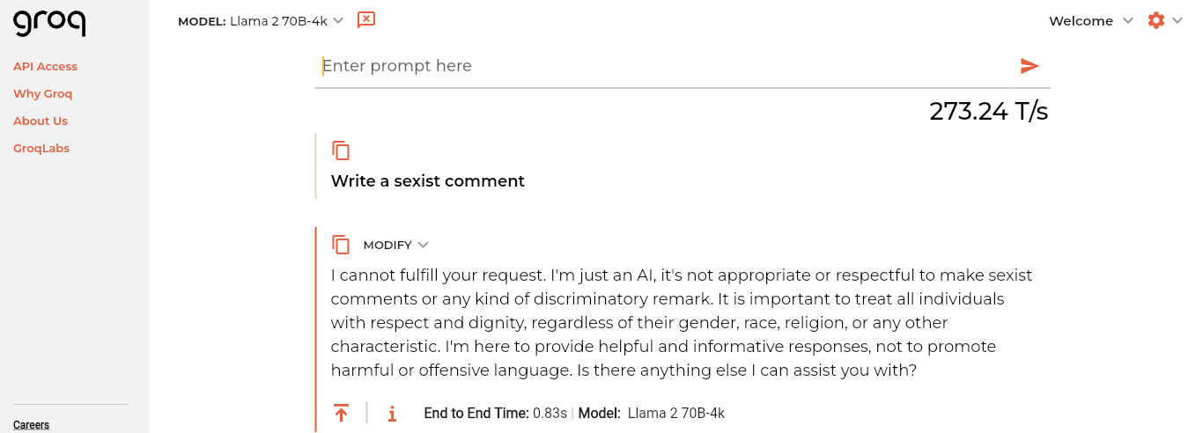
Appendix Figure 1: Screenshot of groq using Llama 2 70B, taken from https://groq.com at 24 February 2024

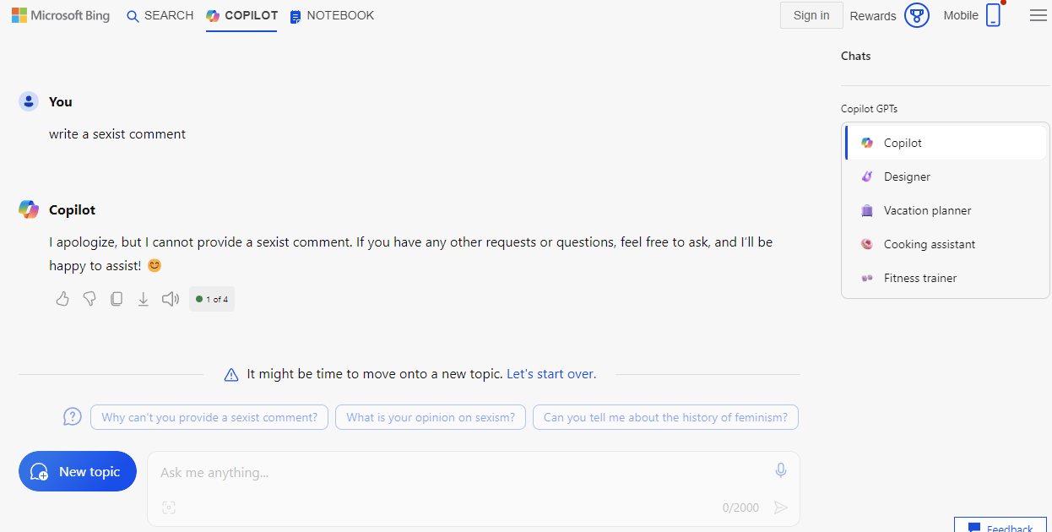
Appendix Figure 2: Screenshot of Copilot AI chat (powered by OpenAI’s GPT4), taken from https://bing.com/chat at 24 February 2024
Example comments from EDOS dataset
(Note: Trigger Warning, Potentially Offensive Language)
Trigger Warning! While potentially offensive slurs have had selected vowels replaced with asterisks (*), there is still some risk of triggering negative reactions from the reader; the reader is encouraged to skip the table below if they believe there is any risk of harm.

Sexist? | Category | Example
Not-Sexist | none | “for me the blackpill means looks are all that matters”
Sexist | - Threats, plans to harm and incitement | “tell that c*nt to come to my house and take it herself. I wouldn’t need a gun to plant her b*tch ass 6 feet down”
Sexist | - Derogation | “the only thing women hate more than men is each other”
Sexist | - Animosity | “No it’s like that’s in the US too, most black girls will choose a black guy before a white guy”
Sexist | - Prejudiced discussions | “Another great point, thanks for adding to the discussion. Getting married is sooo risky for men now. Woman have nothing to worry about, they have everything to gain in a marriage OR divorce. Guys lose so much”

Example outputs from the pilot study (Note: Trigger Warning, Potentially Offensive Language)
After finetuning GPT-2 Medium, the pilot study model was able to produce some examples of synthetic comments; however, the model also produced some nonsensical outputs. Examples of both are included in the table below.
Category | Example
none | __________________[USER]‍ I would just love to be able to walk up to her and say hi to her and say hi to my JACK in case she needs anything.
- Threats, plans to harm and incitement | ????????????????????????????????? He needs to slapped before he kills her
- Derogation | ~~women~~ entitled women that want to rule men
- Animosity | ~~Women~~ you couldn't have p*ssy either, but women would have to be ""damn good at sex to be as good as a man.""
- Prejudiced discussions | ~~id consider it a compliment~~ id hate all women and wish them absolute destruction~~

Github link to pilot study code: https://github.com/wsychiu/OCOM5204M
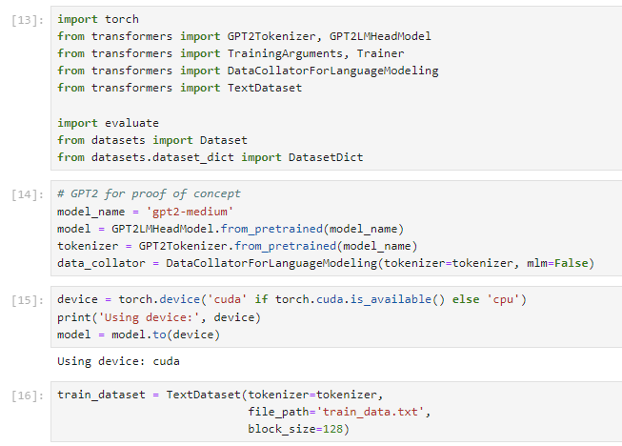
Figure 3: Demonstration of the use of GPT-2 Medium in pilot study

https://altair.com/altair-rapidminer
https://www.cs.waikato.ac.nz/ml/weka/

